Design and apply context-aware access controls based on user identity, device posture, location, and application risk.

GROUP DETAILS:

S.NO | NAMES | COLLEGE NAME | CONTACT
1 | GOKILAVANI.S | AVP College of Arts and Science | gokilavanishamugasundram10@gmail.com
2 | KASTHURI. K | AVP College of Arts and Science | kasthurikannan2005@gmail.com
3 | JESILA PARVEEN. M | AVP College of Arts and Science | jannathulfirthous2212@gmail.com
4 | AMALI. S | AVP College of Arts and Science | amalisakthi15@gmail.com
5 | SURYA. V.S | AVP College of Arts and Science | suryasampath2507@gmail.com

Design and apply context-aware access controls based on user identity, device posture, location, and application risk.

INTRODUCTION:

Modern organizations rely heavily on cloud services, remote work environments, and mobile devices to perform daily operations. As a result, employees, partners, and administrators frequently access organizational resources from different locations and devices, which increases the complexity of maintaining secure access. Traditional security models that depend solely on usernames, passwords, or fixed network boundaries are no longer sufficient to protect sensitive data and critical systems. Cyber threats such as credential theft, device compromise, and unauthorized access attempts require more intelligent and adaptive security mechanisms. This project focuses on designing and implementing a context-aware access control system that evaluates multiple contextual factors before granting access to applications and resources. Instead of relying on a single authentication factor, the system analyzes user identity, device posture, geographic location, and the risk level associated with the requested application to make informed access decisions.
The concept of context-aware access control aligns with modern cybersecurity frameworks such as the Zero Trust security model, which assumes that no user or device should be automatically trusted, even if they are inside the organizational network. In this approach, every access request is continuously verified using real-time contextual information. For example, if a user attempts to log in from a recognized device and a trusted location, the system may allow seamless access. However, if the same user tries to access a high-risk application from an unfamiliar device or unusual geographic location, the system may require additional authentication, limit privileges, or deny access entirely. By dynamically adapting security policies based on contextual risk factors, the system improves protection against unauthorized access and insider threats.
User identity is one of the core components of this system. Identity verification ensures that the person requesting access is legitimate and has the appropriate permissions within the organization. This may involve methods such as multi-factor authentication, role-based access control, and identity verification systems. Device posture is another critical factor that determines whether the device being used meets the organization’s security standards. For example, the system can check whether the device has updated security patches, active antivirus protection, or proper configuration settings before allowing access. If a device fails to meet the required security posture, access may be restricted or monitored closely.
Location awareness also plays an important role in improving access control decisions. The system can analyze login attempts based on geographic location or network context to identify unusual or suspicious activity. For instance, if a user who normally logs in from one region suddenly attempts to access the system from a distant or high-risk location, the system can flag the request as suspicious and trigger additional
verification steps. Similarly, application risk assessment helps determine the level of security required when accessing different resources. High-risk applications, such as financial systems or administrative dashboards,

may require stricter authentication and monitoring compared to low-risk applications like internal communication tools.
By combining these contextual factors, the proposed system creates a dynamic and intelligent security environment that adapts to different situations. The integration of identity verification, device health checks, location monitoring, and application risk assessment enables organizations to implement fine-grained access control policies. This approach not only enhances security but also improves user experience by allowing low-risk access requests to proceed smoothly while applying stricter controls only when necessary. Overall, the project demonstrates how context-aware access control can strengthen modern cybersecurity strategies, reduce potential vulnerabilities, and protect organizational resources in increasingly complex digital environments.

Use Case Scenarios

Scenario 1: Finance Department Access to ERP System
A senior accountant in the finance department needs to access the corporate Enterprise Resource Planning (ERP) system to process monthly payroll. The user connects from a remote location using their company-managed laptop. Upon launching the ZPA Client Connector, they authenticate via Azure Active Directory with multi-factor authentication (MFA). ZPA evaluates the user's identity, group membership (Finance_ERP_Users), device posture (antivirus active, disk encryption enabled), and connection context. The policy engine determines that the user is authorized and brokers a secure, direct micro-tunnel to the ERP application only. The user can interact with the ERP interface, but has no visibility or network-level access to any other internal systems, such as development servers or the HR database.
Output:
- User authenticated and authorized based on identity and group membership
- Direct micro-tunnel established specifically to the ERP application
- All other internal applications and network segments remain invisible and inaccessible

Scenario 2: Contractor Access to Specific Project Repository
An external software consultant is hired for a three-month project and requires access only to a specific Git repository hosted on an internal server. The contractor is onboarded as a guest user in the identity provider and assigned to the "Project_X_Contractors" group. When the contractor connects using the ZPA client, the system verifies their identity and checks the device for basic security compliance (OS patch level, firewall enabled). ZPA enforces a policy that grants access exclusively to the Git repository application (port 22/SSH or port 443/HTTPS) during business hours (9 AM to 5 PM). The contractor can clone, push, and pull code, but cannot discover or connect to any other internal resources, including the corporate intranet or file servers.

Output:
- Time-bound and role-specific access enforced
- Contractor restricted to a single application (Git repository)
- Lateral movement to adjacent systems completely blocked

Scenario 3: Executive Access to Sensitive Financial Documents
A company VP needs to access a folder containing confidential M&A documents stored in a corporate SharePoint site. The user connects from a hotel business center while traveling internationally, using their company- managed tablet. Upon launching the ZPA Client Connector, they authenticate via Azure Active Directory with MFA. ZPA evaluates the user's identity, executive group membership, and device posture (which is compliant). However, the geolocation (unusual foreign country) and the application risk (highly sensitive document repository) trigger an elevated risk score. The policy engine grants access to the SharePoint site, but enforces additional restrictions: download and print capabilities are disabled, and the session is monitored for unusual behavior (e.g., mass download attempts). An alert is also sent to the security team for high-risk executive login. Output:
- User authenticated with MFA and device compliant, but flagged for unusual location
- Read-only access granted with download/print restrictions enforced
- Security team alerted to potential credential misuse or espionage attempt

Scenario 4: Remote Support Technician Access to Internal Tools
An IT support technician needs to access the corporate ServiceNow instance and a remote desktop tool to assist an employee. The technician connects from their home office using a company-managed desktop. Upon launching the ZPA Client Connector, they authenticate via Azure Active Directory with MFA. ZPA evaluates the user's identity, group membership (IT_Support), device posture (fully compliant), and connection type (home office, which is whitelisted for IT staff). Because the user, device, and location all meet the baseline, the policy engine grants direct micro-tunnel access to both ServiceNow and the specific remote desktop jump host used for employee support. The technician can perform their duties efficiently, but still has no access to finance systems, HR databases, or source code repositories.
Output:
- User authenticated and fully authorized based on trusted context
- Direct micro-tunnels established to ServiceNow and the remote desktop jump host
- Least-privilege access maintained; unrelated internal systems remain invisible

Scenario 5: High-Risk Application Access from a Low-Trust Location
A marketing coordinator needs to access the corporate Salesforce instance to update a campaign. The user connects from a coffee shop using their company-managed smartphone. Upon launching the ZPA Client Connector, they authenticate via Azure Active Directory with MFA. ZPA evaluates the user's identity, group
membership (Marketing_Salesforce_Users), device posture (managed and compliant), but flags the public Wi-Fi network as a high-risk connection. The policy engine determines that while the user and device are trusted, the network environment introduces unacceptable risk for direct access to a customer-facing CRM containing sensitive lead data. Instead of blocking access entirely, the user is routed through a secure ZPA browser isolation service, rendering the Salesforce session in a disposable container that prevents any data from persisting on the device or being exposed to the public network.
Output:
- User authenticated and device compliant, but network location deemed high-risk
- Access granted via browser isolation to prevent data leakage on public Wi-Fi
- Session is rendered in a secure container with copy/paste and download controls enforce
STAGE – 1

TITLE:

Design and apply context-aware access controls based on user identity, device posture, location, and application risk.

OVERVIEW:
The modern digital landscape, defined by cloud integration and a decentralized remote workforce, has rendered traditional perimeter-based security—such as static passwords and network boundaries—increasingly ineffective. As organizations expand their access points across diverse devices and locations, the attack surface for credential misuse and unauthorized data infiltration has grown exponentially. Consequently, there is an urgent need to transition toward a Context-Aware Access Control (CAAC) system that prioritizes dynamic, identity-centric verification over legacy, binary trust models.

Operating on Zero Trust principles, this project proposes a system that treats every access request as a unique, high-risk event requiring continuous validation. Instead of relying on a single login prompt, the framework evaluates multiple telemetry signals in real-time, including user identity, device posture, geographic behavior, and application sensitivity. By synthesizing this data into a dynamic "trust score," the system can automatically distinguish between legitimate user activity and potentially malicious behavior, triggering step-up authentication or outright blocks only when necessary.

This adaptive strategy offers a dual benefit of heightened security and operational efficiency by tailoring authentication rigor to the specific risk of the transaction. High-value data remains shielded behind stringent, context-dependent gates, while low-risk interactions proceed with minimal friction, balancing robust protection with a seamless user experience. By integrating these intelligent, automated policies, organizations can effectively fortify their security posture against modern cyber threats while maintaining the agility required for today’s enterprise environments.

List of Vulnerability:

S. No. | Vulnerability Name | CWE No.
1. | Mishandling of Exceptional Conditions | 280
2. | Broken Access Control | 285
3. | SQL Injection | 89
4. | Cryptographic Failures | 331
5. | Insecure Design | 256
6. | Security Misconfiguration | 16
7. | Security Logging and Alerting Failures | 221
8. | Software Supply Chain Failures | 1104
9. | Authentication Failures | 287
10. | Software or Data Integrity Failures | 426

Report:

- Vulnerability Name: Mishandling of Exceptional Conditions

CWE/CVE: 280

OWASP/SANS category: A10:2025
Description: It happens when software fails to prevent, detect, or respond to unusual and unpredictable situations, leading to crashes or unexpected behavior. Instead of failing gracefully, the program may follow insecure code paths, enter an invalid state, or bypass security logic because a critical error was not properly caught or managed.
Business Impact: It can exert a profound business impact, primarily through application instability and logic bypasses. When a system crashes or enters an insecure "fail-open" state due to unhandled permission errors, it risks denial-of-service (DoS) or unauthorized data access. Furthermore, poor handling often leaks sensitive system information via error logs, compromising overall security posture. Hence, implementing robust exception handling and privilege separation is indispensable for ensuring the resilience and operational continuity of an organization’s applications.

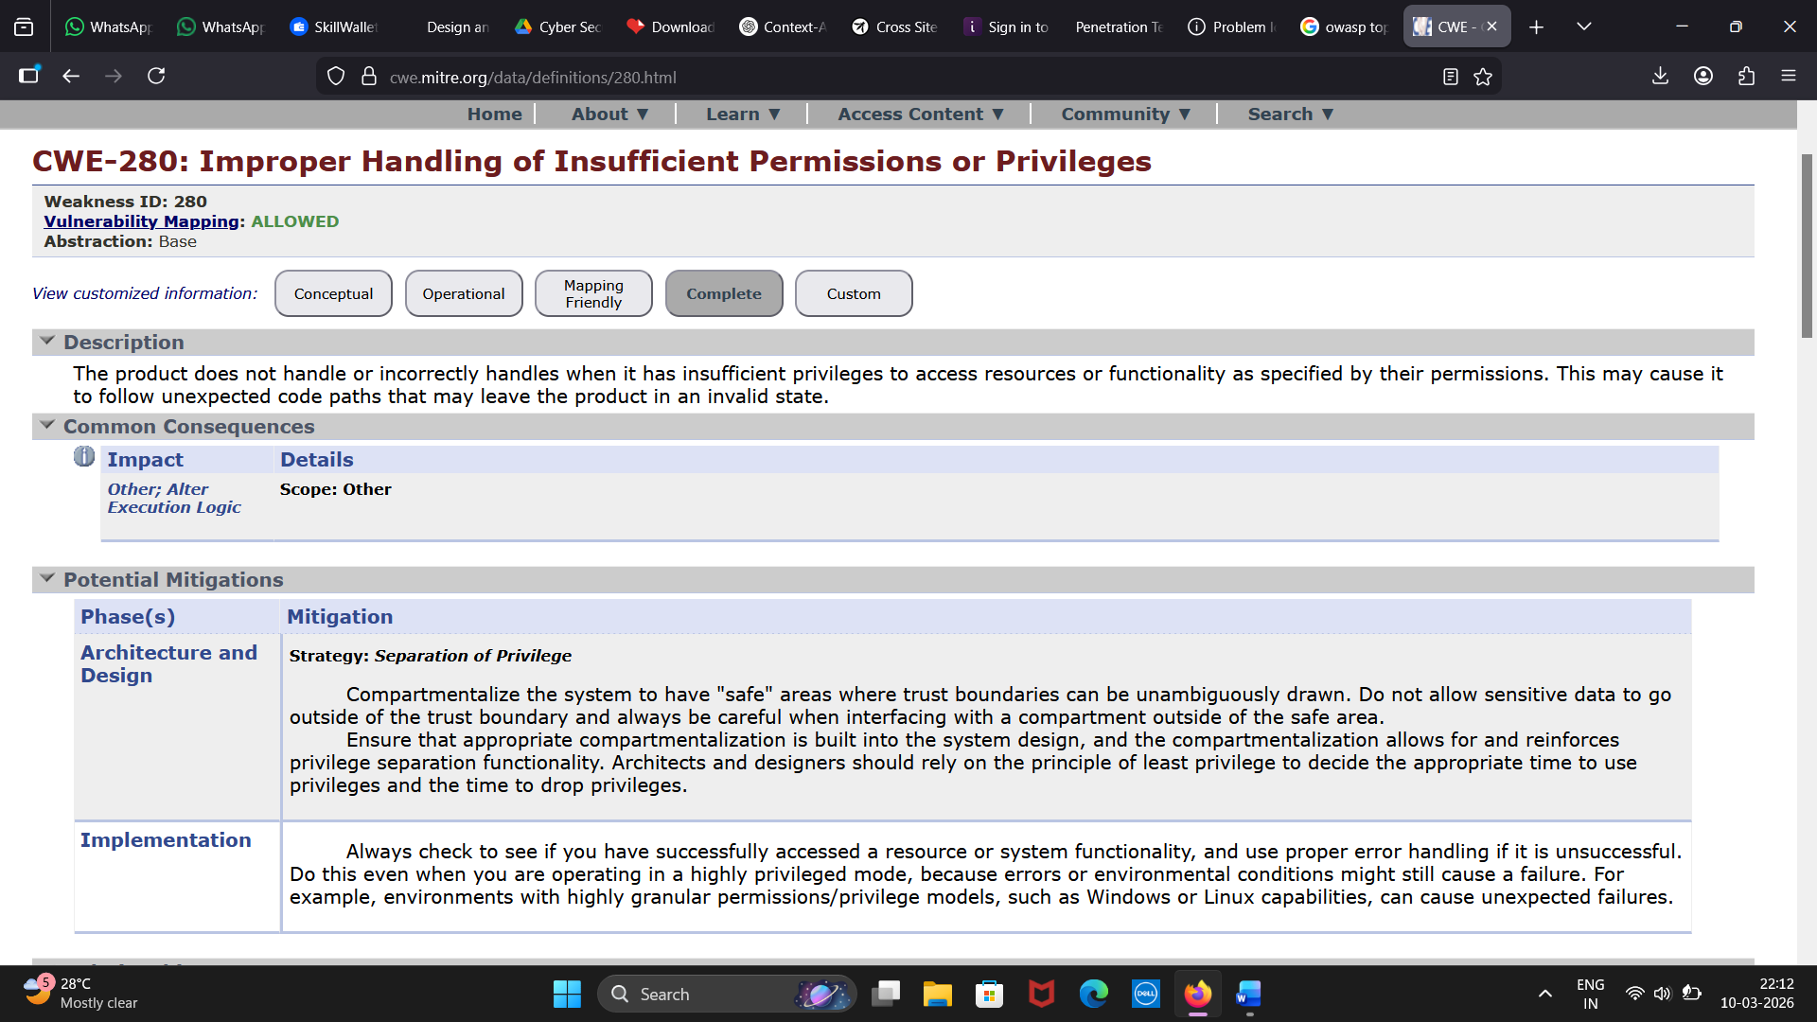

2. Vulnerability Name: Broken Access Control

CWE/CVE: 285

OWASP/SANS Category: A01:2025

Description: When access control checks are not applied consistently - or not at all - users are able to access data or perform actions that they should not be allowed to perform. This can lead to a wide range of problems, including information exposures, denial of service, and arbitrary code execution.
Business Impact: CWE-285 can lead to severe data breaches, unauthorized privilege escalation, and major compliance failures (GDPR/HIPAA). By allowing unauthorized users to act as administrators, it risks total system compromise and irreversible damage to reputation. Maintaining strict access control is indispensable for protecting organizational data.

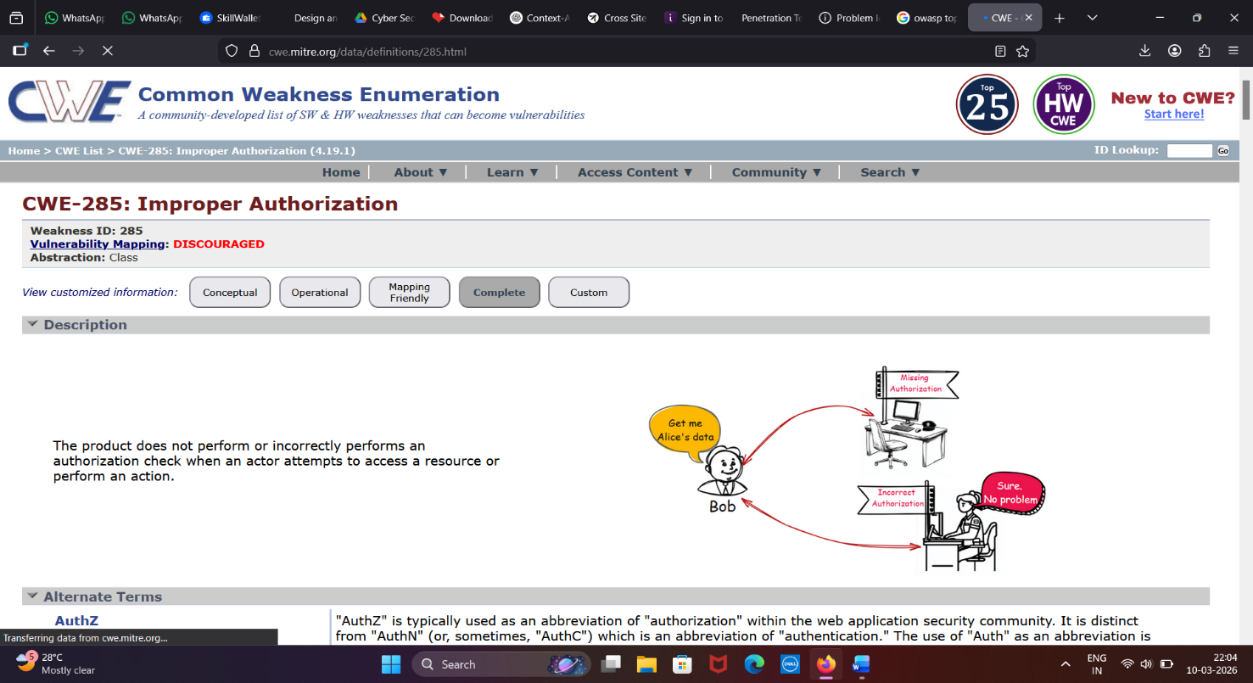

3. Vulnerability Name: SQL Injection

CWE/CVE: 89

OWASP/SANS Category: A05:2025

Description: The product constructs all or part of an SQL command using externally-influenced input from an upstream component, but it does not neutralize or incorrectly neutralizes special elements that could modify the intended SQL command when it is sent to a downstream component.

Business Impact: In summary, it is crucial to underscore that CWE-89, known as SQL Injection, can exert a profound and diverse business impact. This encompasses critical facets such as data breaches, financial setbacks, harm to reputation, legal ramifications, and operational turmoil. Hence, the imperative of preventing and remedying SQL injection vulnerabilities cannot be overstated, as it is indispensable for fortifying the security and continuity of an organization's applications and data.

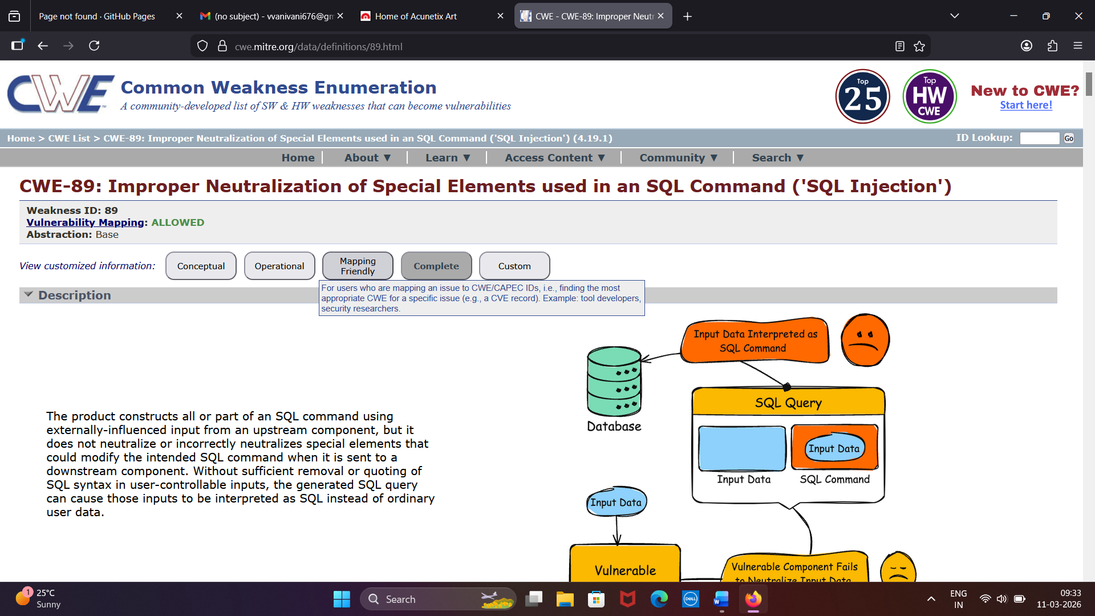

4. Vulnerability name: Cryptographic Failures

CWE/CVE: 331

OWASP/SANS Category: A04:2025

Description: The product uses an algorithm or mechanism that generates insufficient entropy (randomness), resulting in predictable patterns or values that are more likely to occur than others.

Business Impact: CWE-331 can exert a profound business impact through unauthorized access and data decryption. Predictable tokens allow attackers to hijack user sessions or crack encrypted communications, leading to massive data breaches and financial loss. Hence, implementing cryptographically strong random number generators (CSPRNGs) is indispensable for maintaining the integrity and confidentiality of an organization's digital assets.

.

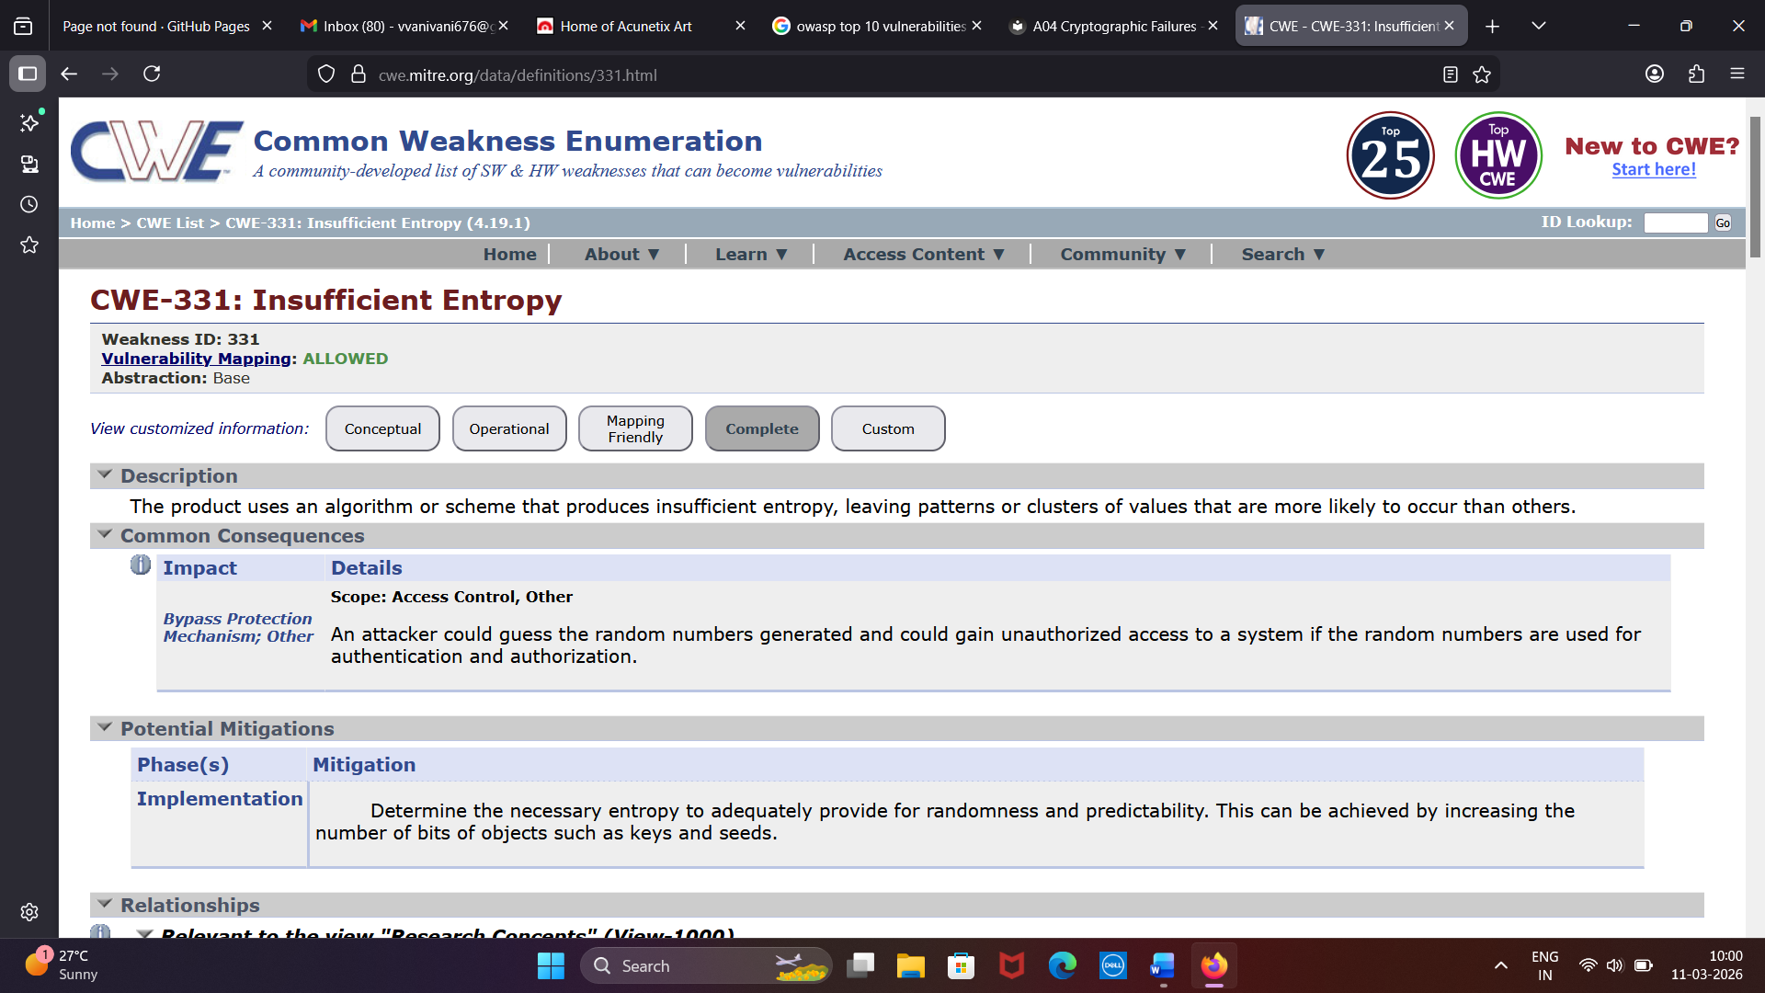

5. Vulnerability Name: Insecure Design

CWE/CVE: 256

OWASP/SANS Category: A06:2025

Description: The product stores a user password in plaintext within resources such as memory, files, or databases, without using encryption or hashing mechanisms to protect it.

Business Impact: Storing passwords in plaintext creates a serious security risk because attackers who access the database or system files can immediately view user credentials. This may allow unauthorized access to user accounts and sensitive organizational systems. It can lead to data breaches, identity theft, and misuse of confidential information. Such incidents can damage customer trust and harm the organization’s reputation. Additionally, companies may face financial losses and legal consequences due to poor security practices.

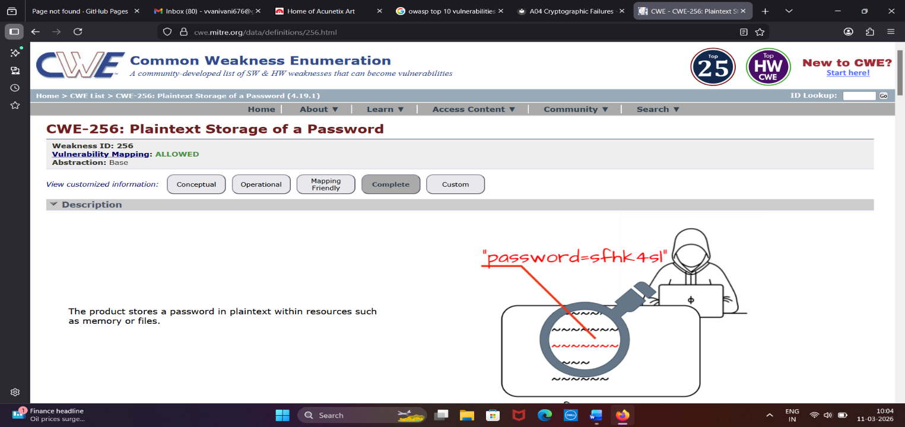

6. Vulnerability Name: Security Misconfiguration

CWE/CVE: 16

OWASP/SANS Category: A02:2025

Description: Configuration weaknesses occur when software or systems are not securely configured during installation or deployment, creating security gaps that attackers can exploit.

Business Impact: Security misconfigurations can expose sensitive data and critical system resources to unauthorized access. Attackers may exploit these weaknesses to gain control of systems or disrupt services. This can result in data breaches, compliance violations, and operational downtime. Consequently, organizations may experience financial losses and damage to their reputation.

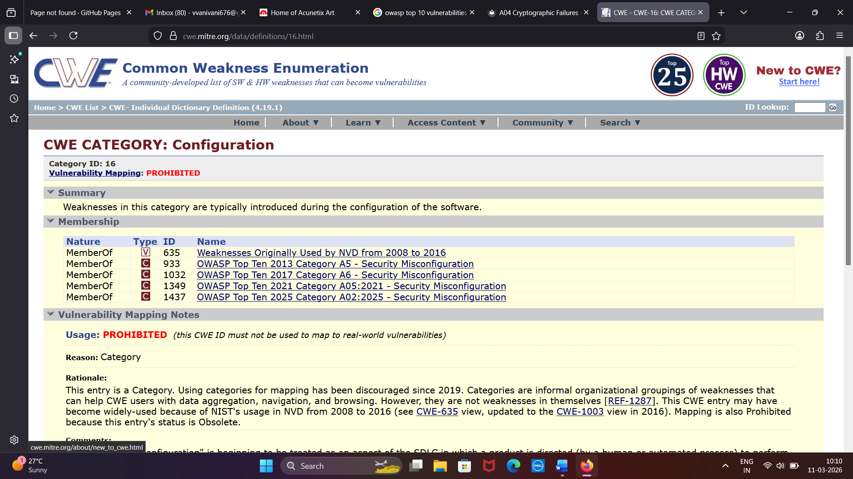

7. Vulnerability Name: Security Logging and Alerting Failures

CWE/CVE: 221

OWASP/SANS Category: A09:2025

Description: It refers to a security weakness where a system fails to record or properly capture important security-related information. This may occur when logs are incomplete, certain events are not recorded, or critical details are omitted during data collection or reporting. As a result, security teams may lack the necessary information to analyze incidents, detect attacks, or understand the sequence of events within the system.

Business Impact: Information loss or omission can reduce an organization’s ability to detect and investigate security incidents. Missing or incomplete logs make it difficult to trace malicious activities or identify the root cause of attacks. This may lead to delayed response and ineffective security monitoring. As a result, organizations may face data breaches, compliance issues, and operational disruptions. Ultimately, it can cause financial losses and damage to the organization’s reputation.

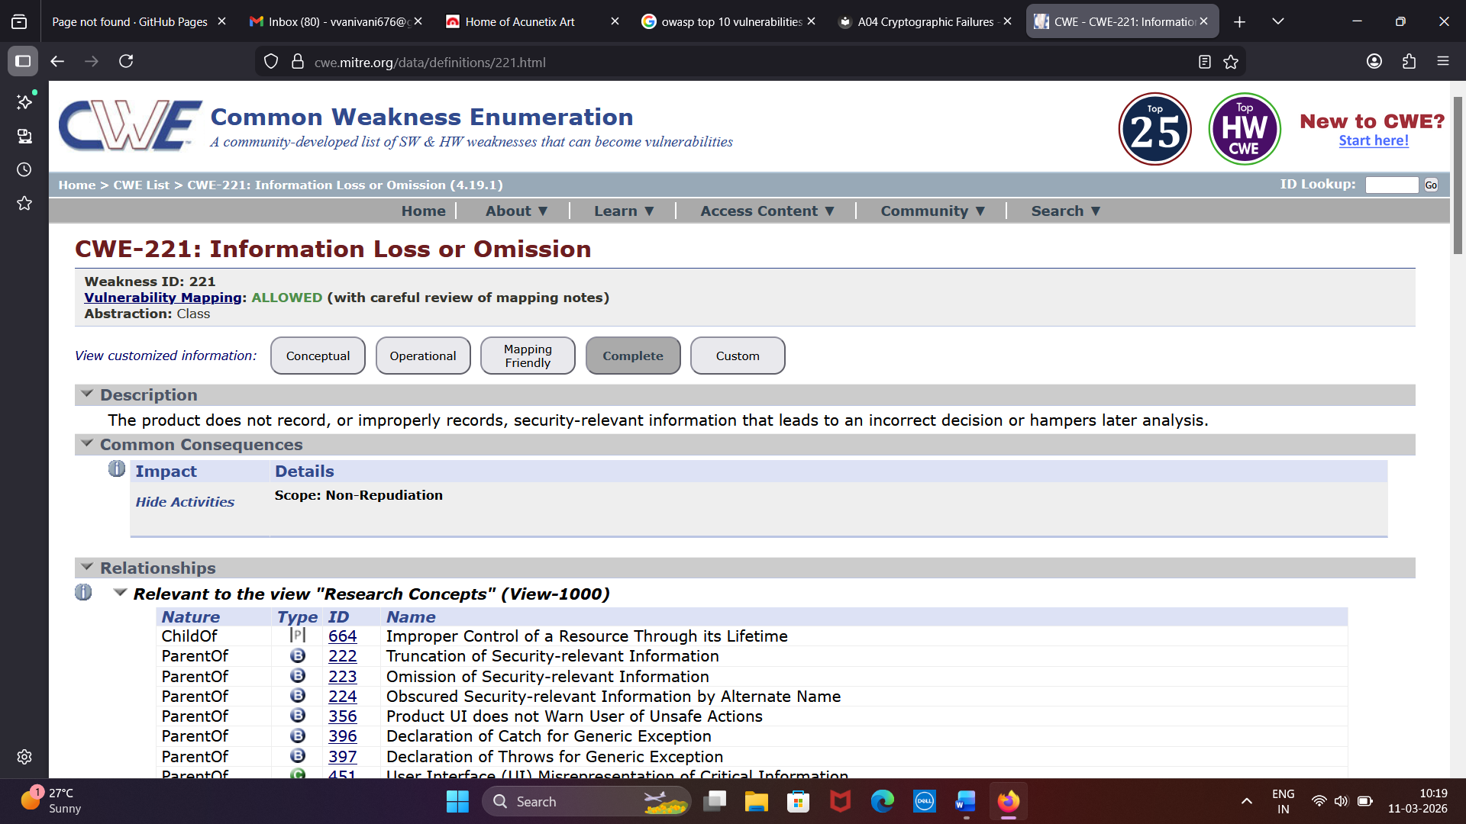

8. Vulnerability name: Mishandling of Exceptional Conditions

CWE/CVE: 1104

OWASP/SANS Category: A03:2025
Description: It occurs when an application relies on third-party libraries or components that are no longer actively maintained or supported by their developers. These outdated components may contain known vulnerabilities that remain unpatched and exploitable.
Business Impact: Using unmaintained third-party components can expose applications to known security vulnerabilities that attackers can easily exploit. This may lead to unauthorized access, data breaches, or compromise of critical systems. Since these components no longer receive security updates, the risk of exploitation increases over time. A successful attack can disrupt business operations, cause financial losses, and lead to regulatory compliance issues. Additionally, security incidents resulting from vulnerable components can damage the organization’s reputation and reduce customer trust.

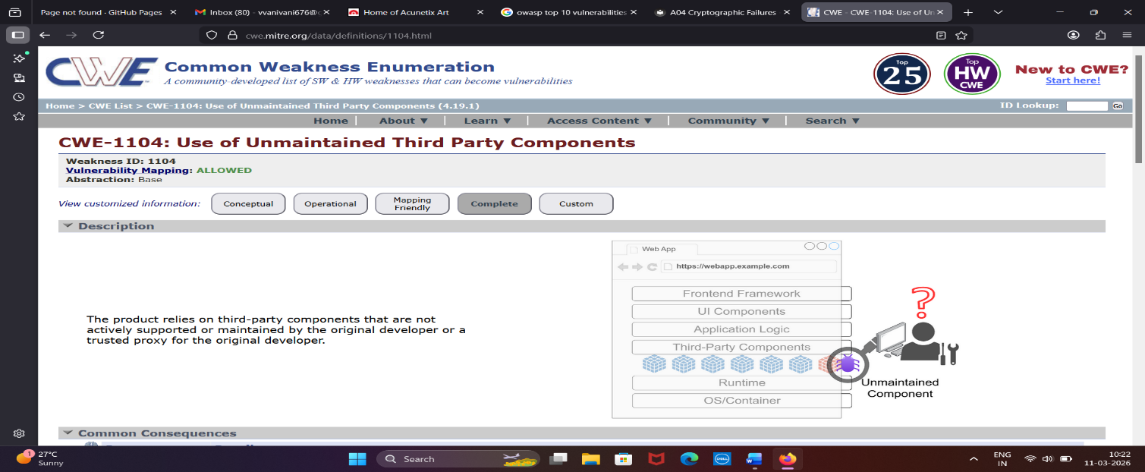

9. Vulnerability Name: Aunthentication Failures

CWE/CVE: 287

OWASP/SANS Category: A07:2025
Description: It occurs when an application fails to properly verify the identity of a user, system, or entity requesting access. As a result, attackers may bypass authentication controls and gain unauthorized access to protected resources.
Business Impact: Improper authentication can allow attackers to impersonate legitimate users and gain unauthorized access to sensitive systems or data. This may lead to exposure of confidential information, unauthorized transactions, or manipulation of critical business data. If exploited, attackers could compromise user accounts, disrupt services, or escalate their privileges within the system. Such incidents can result in financial losses, regulatory compliance violations, and significant damage to the organization’s reputation and customer trust.

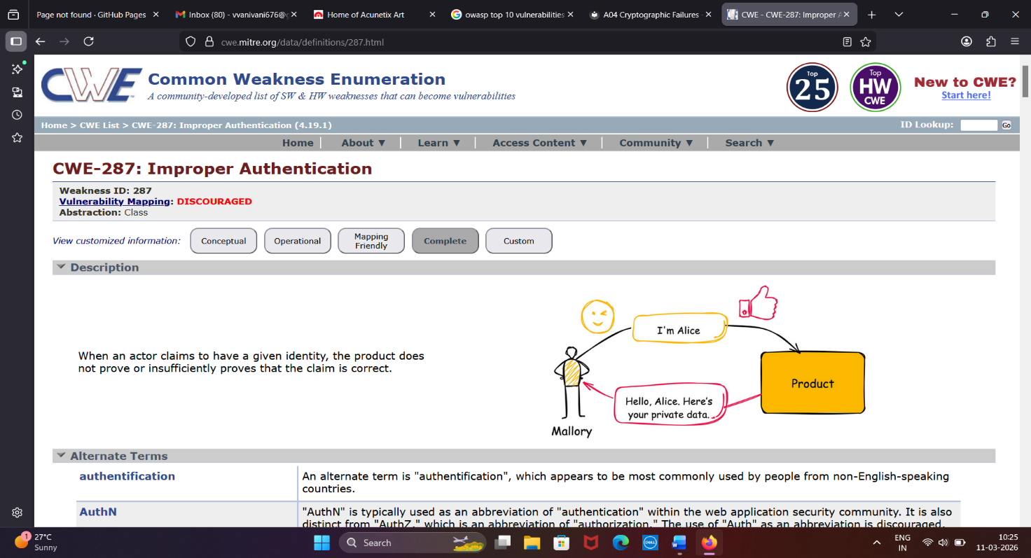

10. Vulnerability Name: Software or Data Integrity Failures

CWE/CVE: 426

OWASP/SANS Category: A08:2025

Description: It occurs when an application loads executables, libraries, or resources from a search path that may include untrusted or attacker-controlled directories. Attackers can place malicious files in these locations, causing the application to execute the malicious file instead of the intended trusted resource.
Business Impact: This vulnerability can allow attackers to execute malicious code within the affected system or application, potentially leading to system compromise and unauthorized access to sensitive data. Successful exploitation may enable attackers to modify system behavior, install malware, or gain elevated privileges. Such incidents can disrupt normal business operations, affect service availability, and lead to data loss or manipulation. Additionally, organizations may face financial losses, regulatory penalties, and reputational damage if attackers exploit this weakness to compromise critical systems or user data.
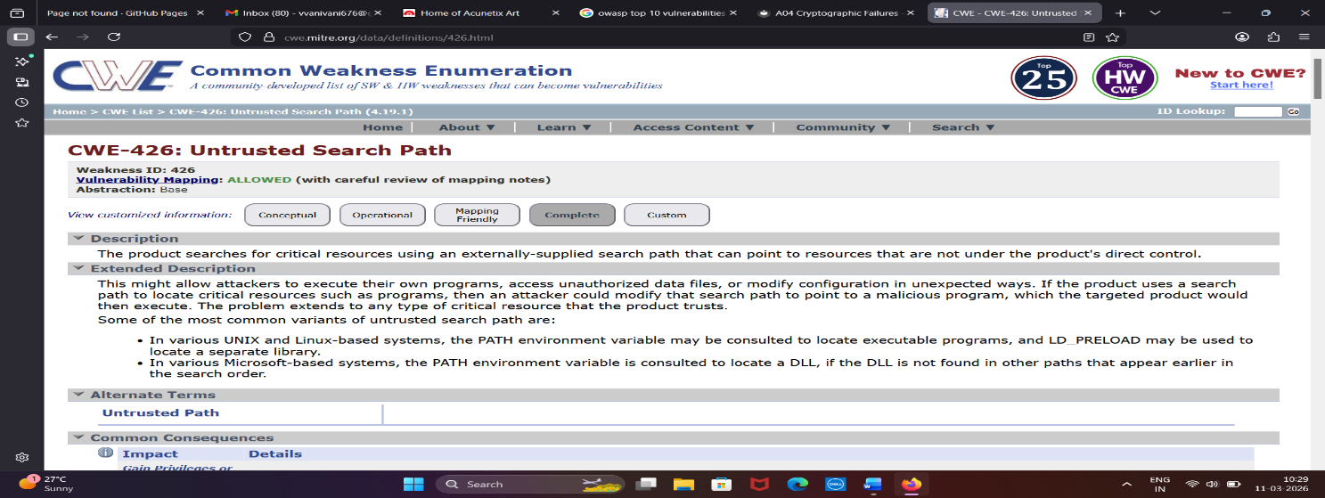

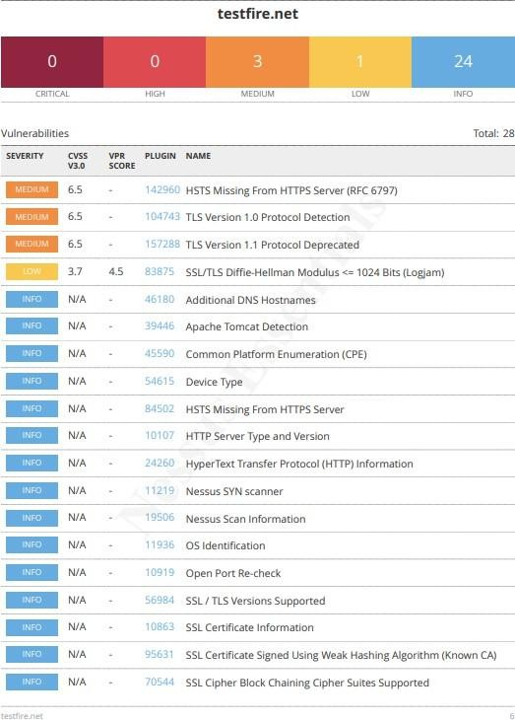
NESSUS SCAN REPORT
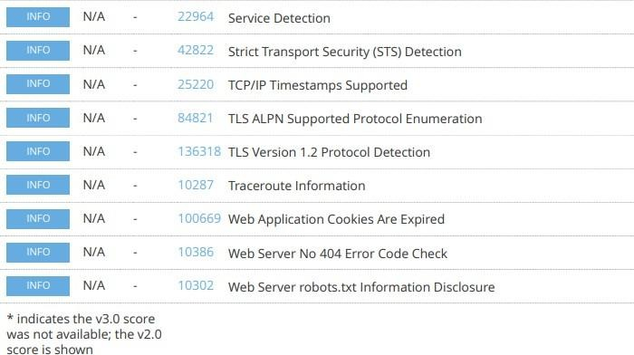
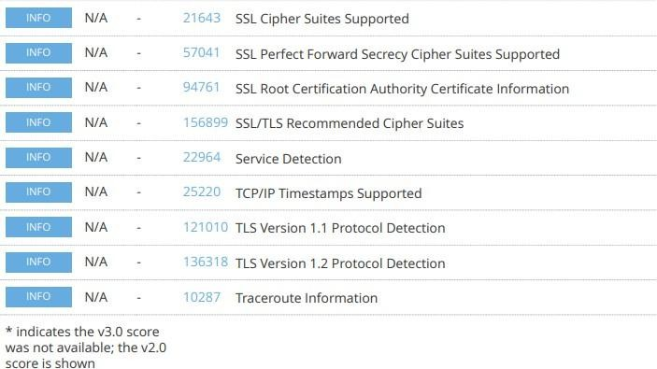
"With the Nessus scan report now at our disposal, we're equipped with critical data on the existing vulnerabilities and potential threats. This invaluable information will serve as a foundation for our project planning phase, as we chart the course to develop our AI-driven incident response platform with a well- informed strategy and timeline."

STAGE – 2

OVERVIEW:
An overview of a Nessus scan typically involves the following key steps and aspects:

- Preparation: Define Objectives: Determine the scope and objectives of the scan. What systems or networks do you want to assess, and what specific vulnerabilities are you looking for?

System Access: Ensure that you have the necessary permissions and access rights to scan the target systems or networks.
- Configuration: Set Up Scan Policy: Create a scan policy that defines the parameters of the scan, such as the types of vulnerabilities to check for, scanning frequency, and specific configurations.
Define Target Assets: Specify the IP addresses, hostnames, or network ranges of the systems you want to scan.
- Scanning: Initiate Scan: Start the Nessus scan using the configured policy and target assets. Nessus will systematically scan the target systems for vulnerabilities based on its plugins and policies.

- Vulnerability Identification: Nessus performs a comprehensive assessment, checking for vulnerabilities, misconfigurations, open ports, and other security issues. As the scan progresses, it categorizes vulnerabilities by severity, making it easier to prioritize remediation efforts.

- Reporting: Nessus generates detailed reports that list the vulnerabilities discovered during the scan. Reports typically include information about the severity of each vulnerability, recommended actions for remediation, and supporting evidence. These reports can be customized and exported in various formats, such as PDF, HTML, or CSV.

- Remediation: Review Findings: IT and security teams review the Nessus scan reports to prioritize and address the identified vulnerabilities.

Remediation Steps: Take corrective actions to fix or mitigate the vulnerabilities. This may involve applying patches, changing configurations, or implementing security measures.

- Follow-up: Regular Scanning: Conduct periodic Nessus scans to continuously monitor the security posture of the systems and networks. This helps identify new vulnerabilities and track progress in mitigating existing ones.
Integration: Integrate Nessus with other security tools or workflows to automate the vulnerability management process and streamline the response to new findings.

- Compliance Auditing (if applicable): If compliance checks are part of your scan policy, review compliance results and take actions to ensure systems meet the required standards and regulations.

- Documentation: Maintain records of scan results, remediation efforts, and compliance checks for audit and reporting purposes.

- User Training: Ensure that your IT and security teams are trained in using Nessus effectively and interpreting scan results.

Nessus scans are a critical component of proactive security, helping organizations identify and address vulnerabilities in their IT infrastructure to reduce the risk of security breaches and data compromises. The frequency and depth of scans can vary depending on an organization's security strategy and requirements.
Nessus is a popular vulnerability scanning tool used for identifying security weaknesses in computer systems and networks. It is widely utilized by security professionals and organizations to assess the security posture of their systems and to proactively identify potential vulnerabilities that could be exploited by attackers. Here's what I understand about Nessus scans:
- Vulnerability Assessment: Nessus performs a vulnerability assessment by scanning target systems or networks to identify security issues, such as missing patches, misconfigurations, weak passwords, and other potential weaknesses that could be exploited by attackers.
- Network Scanning: Nessus can scan a wide range of network devices, including servers, routers, switches, firewalls, and more. It examines network services, open ports, and software running on target systems.
- Plugin Architecture: Nessus uses a plugin-based architecture, allowing it to check for a wide variety of vulnerabilities. These plugins are regularly updated to include the latest security checks and support for new vulnerabilities.

- Compliance Auditing: It can also be used to assess systems against various compliance standards and regulatory requirements, helping organizations ensure that their systems meet specific security.
- Customization: Nessus scans can be customized to suit the specific needs of an organization. Users can define scan policies, select the target systems, and specify the types of vulnerabilities to scan for.
- Reporting: Nessus provides detailed reports that highlight vulnerabilities, their severity, and remediation recommendations. These reports are essential for IT and security teams to prioritize and address vulnerabilities.

- Scanning Frequency: Organizations often perform regular Nessus scans to continuously monitor and improve their security posture. This is crucial for staying ahead of evolving threats and vulnerabilities.
- Integration: Nessus can be integrated with other security tools and platforms, allowing organizations to automate the scanning process and streamline their vulnerability management.

- Licensing: Nessus offers both free and commercial versions. The free version is limited in its functionality, while the commercial version provides more features and support.
- User-Friendly Interface: Nessus offers an easy-to-use web-based interface, making it accessible to a wide range of users, from security experts to less experienced IT professionals.

It's important to note that Nessus is a valuable tool for identifying vulnerabilities, but it doesn't fix these vulnerabilities itself. It's up to the organization's IT and security teams to take the necessary steps to remediate the identified issues to enhance their security.

S. No | Vulnerability Name | Severity | Plugins
1. | Common Platform Enumeration (CPE) | info | 45590
2. | Device Type | info | 54615
3. | Host Fully Qualified Domain Name (FQDN) Resolution | info | 12053
4. | Nessus Scan Information | info | 19506
5. | Nessus SYN scanner | info | 11219
6. | OS Fingerprints Detected | info | 209654
7. | OS Identification | info | 11936
8. | Service Detection (HELP Request) | info | 11153
9. | TCP/IP Timestamps Supported | info | 25220
10. | Traceroute Information | info | 10287

Target Website: testfire.net

Target IP Address: 54.83.41.36

Report:

- VULNERABILITY NAME: Common Platform Enumeration (CPE)
SEVERITY: Info
PLUGIN : 45590
PORT: N/A
DESCRIPTION:
By using information obtained from a Nessus scan, this plugin reports CPE (Common Platform Enumeration) matches for various hardware and software products found on a host.

SOLUTION:
- Review the hardware and software products identified in the scan.
- Verify that the detected products are correctly installed on the host system.
- Ensure all identified software and systems are updated with the latest patches.
- Regularly monitor and review scan results.
- Take necessary actions to manage or reduce potential vulnerabilities.

BUSINESS IMPACT:
If the hardware and software information of a system is exposed, attackers may identify the technologies running on the host and look for known vulnerabilities in those products. If any outdated or vulnerable software is present, it can be exploited to gain unauthorized access or compromise the system. This may lead to security risks such as data breaches, system disruption, or loss of sensitive information, which can negatively affect the organization’s operations and overall security.

- VULNERABILITY NAME: Device Type
SEVERITY: info
PLUGIN: 54615
PORT: N/A
DESCRIPTION :
Based on the remote operating system, it is possible to determine the type of the remote system, such as a printer, router, IoT device, or general-purpose computer. This information can be obtained through techniques like operating system fingerprinting, where network responses, open ports, and
service banners reveal details about the operating system running on the target device. Attackers can use this information during the reconnaissance phase to better understand the network environment and identify potential targets. Knowing the operating system and device type allows attackers to focus on specific vulnerabilities associated with that platform, increasing the likelihood of a successful attack.

SOLUTION:
To mitigate this issue, organizations should minimize the amount of system information exposed to external users. This can be achieved by disabling or modifying service banners that reveal operating system details, closing unnecessary ports and services, and implementing firewall rules to restrict unauthorized access. Additionally, deploying intrusion detection or prevention systems (IDS/IPS), applying regular security patches, and following system hardening best practices can help reduce the effectiveness of OS fingerprinting and limit the information available to potential attackers.

BUSINESS IMPACT:
If attackers are able to determine the operating system and device type of remote systems, they may use this information to launch targeted attacks against known vulnerabilities associated with those platforms. This could lead to unauthorized access, system compromise, data breaches, or disruption of business services. Such incidents may result in financial losses, operational downtime, regulatory penalties, and damage to the organization’s reputation. Limiting the exposure of system information helps reduce the risk of targeted exploitation.

- VULNERABILITY NAME: Host Fully Qualified Domain Name (FQDN) Resolution

SEVERITY: Info

PLUGIN: 12053
PORT: N/A
DESCRIPTION:
The statement means that Nessus was able to identify the Fully Qualified Domain Name of the scanned system. An FQDN is the complete domain name of a host that includes the hostname and domain.
During the scan, Nessus performed a DNS lookup and successfully resolved the IP address of the remote host to its corresponding domain name. This indicates that the system’s DNS information is publicly accessible or properly configured to respond to DNS queries.This finding is generally informational and simply shows that the scanner could determine the full domain name associated with the target host.

SOLUTION:
To reduce the exposure of the fully qualified domain name (FQDN), organizations should limit unnecessary DNS information disclosure by properly configuring DNS servers and network services. Internal hostnames should not be publicly exposed unless required for business operations. Implementing split DNS (separate internal and external DNS records), restricting DNS zone transfers, and configuring firewalls to allow DNS queries only from authorized systems can help minimize information leakage. Additionally, review DNS records regularly and remove or hide unnecessary hostnames that may reveal internal infrastructure details.

BUSINESS IMPACT:
If the Fully Qualified Domain Name (FQDN) of a system is exposed, attackers may gain information about the organization’s network structure and internal naming conventions. This information can help them identify potential targets and plan further reconnaissance or attacks. Although this issue is mainly informational, it can assist attackers in gathering useful details about the organization’s infrastructure.

- VULNERABILITY NAME: Nessus Scan Information
SEVERITY: INFO
PLUGIN: 19506
PORT: N/A

DESCRIPTION:
This plugin from Nessus provides general information about how the vulnerability scan was performed on each host. It reports details such as the plugin set version, scanner type, Nessus engine version, port scanners used, port range scanned, and ping round-trip time. It also shows whether credentialed checks or third-party patch checks were possible, whether superseded patches are displayed, the scan date, scan duration, and how many hosts and checks were processed in parallel. This information helps administrators understand the configuration and execution details of the scan.

SOLUTION:
No specific action is required because this plugin only provides informational details about the scan. However, administrators should review the scan information to ensure the scan was configured correctly, verify that the correct port ranges and credentials were used, and confirm that the scan covered all required hosts and services.

BUSINESS IMPACT:
There is no direct security risk associated with this finding since it only reports scan configuration details. However, reviewing this information helps ensure that vulnerability scans are performed correctly and completely. Proper scan configuration improves the accuracy of vulnerability detection and supports better security management within the organization.

5. VULNERABILITY NAME: Nessus SYN scanner

SEVERITY: Info
PLUGIN: 11219
PORT: N/A

DESCRIPTION:
This plugin in Nessus performs a SYN half-open port scan to identify open ports on the target system. In this method, the scanner sends a SYN request to the target host to check whether a port is open. If the port responds, the scanner identifies it as open without completing the full TCP connection. This type of scan is faster and less intrusive than a full TCP connection scan, but it may still affect weaker firewalls or leave incomplete connections on the target system, especially when the network is heavily loaded.

SOLUTION:
Protect the target system by using an IP filtering mechanism or firewall. Configure the firewall to allow only trusted IP addresses and block unauthorized scanning attempts. Regularly monitor network traffic and update firewall rules to reduce the risk of unauthorized port scanning.

BUSINESS IMPACT:
If attackers perform SYN port scans, they may discover open ports and running services on the system. This information can help them identify potential entry points for further attacks. If the firewall or network security controls are weak, it could expose critical services.

6. VULNERABILITY NAME: OS Fingerprints Detected

SEVERITY: INFO

PLUGIN: 209654
PORT: N/A
DESCRIPTION:
This plugin in Nessus collects information about the operating system of the remote host by using different network probes such as TCP/IP, SMB, HTTP, NTP, and SNMP. These probes help the scanner identify the system’s characteristics and generate fingerprints that indicate the possible operating system running on the target machine. The most accurate result is reported in the OS Identification, while this plugin lists all the fingerprints detected during the scan.

SOLUTION:
Limit unnecessary exposure of system information by restricting access to network services.

Configure firewalls and security controls to allow only trusted connections and disable unused services. Regularly monitor and manage network services to prevent unauthorized system identification.

BUSINESS IMPACT:
If attackers can fingerprint a system and identify its operating system, they may use this information to search for known vulnerabilities related to that OS. This can help them plan targeted attacks against the system. Although this finding is mainly informational, it may assist attackers in gathering useful details about the organization’s infrastructure.

7. VULNERABILITY NAME: OS Identification

SEVERITY: INFO

PLUGIN: 11936
PORT: N/A
DESCRIPTION:
OS Identification means detecting the operating system running on a remote host using network fingerprinting techniques. The scanner sends different network probes (TCP/IP, SMB, HTTP, SNMP, etc.) and analyzes the response to determine the operating system such as Microsoft Windows, Linux, or macOS.This information is used during vulnerability assessment to understand the target environment.

SOLUTION:
To reduce the risk of OS identification:
- Configure firewalls to block unnecessary probes.
- Disable unnecessary network services.
- Use network filtering and intrusion detection systems.
- Implement OS fingerprinting protection mechanisms.

BUSINESS IMPACT:
- Attackers may gain information about system infrastructure.
- Increases the risk of targeted cyber attacks.
- May lead to data breaches or system compromise if vulnerabilities are exploited.

8. VULNERABILITY NAME: Service Detection (HELP Request)

SEVERITY: info
PLUGIN: 11153
PORT: port 80
DESCRIPTION:
The scan detected that a remote service reveals information through its banner or error
message when a HELP request is sent. This means an attacker can identify what service or application is running on the server by analyzing the response. Tools like Nessus use this technique to detect services and their versions.

SOLUTION:
To reduce this information exposure:
- Disable banner disclosure on services and servers.
- Configure servers to hide version information in responses.
- Modify service configuration to block or restrict HELP commands if not required.

BUSINESS IMPACT:
- Attackers can identify the software or service running on the system.
- This information helps attackers find known vulnerabilities in that service.
- It increases the risk of targeted attacks and system compromise.
- If exploited, it may lead to data breaches, service disruption, or financial loss.

9. VULNERABILITY NAME: TCP/IP Timestamps Supported

SEVERITY: Info

PLUGIN: 25220
PORT: port 80/443

DESCRIPTION:
The remote host supports TCP timestamps, which are defined in RFC 1323.
This feature helps improve network performance by providing more accurate packet timing and sequence tracking. However, attackers may analyze these timestamps to estimate the system uptime (how long the system has been running).

SOLUTION:
To reduce the risk of information disclosure:
- Disable TCP timestamps in the operating system network settings.
- Apply system hardening policies to limit unnecessary information leakage.

- Use firewalls or security controls to restrict external access to system information.
- Regularly update and patch the operating system such as Microsoft Windows or Linux.

BUSINESS IMPACT:
  - Attackers may estimate system uptime and gather information about system behavior.
- This information can help attackers plan targeted attacks or exploitation attempts.
- Although the risk is low, it contributes to information disclosure about the system infrastructure.

10. VULNERABILITY NAME: Traceroute Information
SEVERITY: Info
PLUGIN: 10287
PORT: N/A
DESCRIPTION:
The scan performed a traceroute to the remote host to determine the network path taken by packets from the scanner to the target system. Traceroute identifies the intermediate routers and network devices involved in the communication. Security tools like Nessus use this information to analyze network routing and connectivity.

SOLUTION:
To limit exposure of network path information:
- Configure firewalls to restrict traceroute-related traffic (ICMP, UDP, or TCP).

- Implement network security controls to prevent unnecessary network discovery.
- Monitor network traffic using intrusion detection systems.

BUSINESS IMPACT:
- Attackers can discover network structure and routing paths.
- This information may help attackers map the internal or external network infrastructure.
- It can assist attackers in planning targeted network attacks or reconnaissance activities.

STAGE – 3

TITLE:
Design and apply context-aware access controls based on user identity, device posture, location, and application risk.

Context-aware access controls represent the operational pinnacle of a Zero Trust architecture, moving beyond static rules to create a dynamic and adaptive security perimeter around every application. In a modern enterprise, where users are mobile, devices are diverse, and threats are sophisticated, granting access based solely on a username and password is a dangerous oversimplification. Designing and applying context-aware controls means building a policy engine that consumes multiple, real-time signals about an access request and renders an intelligent decision: to allow, to block, to limit, or to challenge. This approach ensures that the security posture is not a flat, always-on gate but a responsive system that tightens or loosens based on the risk of the specific moment.

Context-aware access controls are the operational peak of Zero Trust, creating a dynamic security perimeter that evaluates multiple real-time signals to make intelligent access decisions. The first layer, user identity, leverages attributes from Identity Providers like Azure AD or Okta, combining multi-factor authentication and group/role memberships for granular, function-specific policies. The second layer, device posture, continuously monitors endpoints via EDR and MDM tools, assessing encryption, antivirus status, patch levels, and compromise risk, triggering restricted or remediation access when necessary.

The third layer, location and network context, evaluates connection points and network security, enforcing stricter controls for untrusted or foreign networks while enabling step-up authentication when needed. The fourth layer, application risk, categorizes applications by sensitivity, applying proportionate controls so critical apps require alignment of all layers, potentially with additional restrictions like session recording or time-of-day access. Together, these layers form adaptive, context-sensitive policies that ensure resources are protected according to risk, operationalizing the Zero Trust principle: never trust, always verify.

It represent the operational pinnacle of Zero Trust architecture, moving beyond static password-based rules to create a dynamic, adaptive security perimeter around every application and access attempt. The system evaluates multiple real-time signals to make intelligent decisions—whether to allow, block, limit, or challenge access—based on the current risk context. The first layer, user identity, leverages rich attributes from corporate Identity Providers such as Azure AD or Okta, incorporating multi-factor authentication, group memberships, roles, and departmental information to enable highly granular, function-specific policies. The second layer, device posture, continuously monitors endpoints through integrations with

Endpoint Detection and Response (EDR) tools like CrowdStrike or SentinelOne and Mobile Device
Management (MDM) solutions like JAMF or Intune, checking factors such as disk encryption, antivirus
status, patch compliance, root/jailbreak status, and reported risk scores, with policy-driven actions including full access denial, limited remediation access, or guidance to correct vulnerabilities.

The third layer, location and network environment, evaluates both physical and virtual connection points, distinguishing between trusted corporate networks, known home IPs, and high-risk locations or anonymized connections, while also assessing network security such as public Wi-Fi usage to enforce step-up authentication or restricted access as needed. The fourth layer, application risk, classifies applications based on sensitivity, from low-risk internal wikis to critical financial systems or intellectual property repositories, applying layered and dynamic policies that adjust access requirements proportionally, potentially incorporating session recording, read-only modes, or time-of-day restrictions for higher-risk resources.

Together, these four layers—identity, device posture, location, and application risk—form a responsive, context-sensitive access control framework. By integrating these signals through platforms like Zscaler Private Access (ZPA), organizations can create finely tuned policies that adapt to changing circumstances, prevent lateral movement of threats, and ensure that security resources are applied where they matter most, effectively operationalizing the Zero Trust principle of “never trust, always verify.”

Conclusion:
Stage 1: Enhanced User Identity Verification The future of Stage 1 in context-aware access control focuses on advanced user identity verification. Biometric methods like fingerprint, facial, and voice recognition will provide stronger, more reliable authentication than passwords. Behavior-based authentication will analyze patterns such as typing speed and login habits to detect anomalies. Deviations can trigger additional verification or restrict access in real time. Integration with IAM platforms from Microsoft, Okta, and Google will enable centralized management and adaptive security policies. Multi-factor and risk-based authentication will become more intelligent and seamless. These enhancements make identity verification more secure, automated, and user-friendly. Overall, Stage 1 will strengthen access control and protect organizational resources effectively.

Stage 2: The future of Stage 2 in context-aware access control emphasizes proactive device and system security assessment. Continuous, real-time monitoring will detect emerging threats beyond periodic scans. Automated patch management can apply fixes, reconfigure settings, or isolate high-risk devices to reduce exposure. AI and machine learning will predict vulnerabilities and prioritize remediation before attacks occur. Integration with EDR and MDM platforms ensures security throughout the device lifecycle. Mobile and IoT devices will remain continuously compliant as conditions change. Contextual risk scoring will

dynamically adjust access based on device risk. Overall, Stage 2 will enable intelligent, automated, and adaptive security enforcement for a stronger Zero Trust posture.

Stage 3:The implementation of Zscaler Private Access marks a pivotal shift from a vulnerable, network- centric security model to a resilient, identity-centric Zero Trust architecture. By enforcing least- privilege access and rendering private applications invisible to the internet, this project effectively neutralizes the threats of lateral movement and network-based attacks. The solution not only fortifies the organization's security posture against modern cyber threats but also delivers a seamless and high-performance experience for a distributed workforce. Furthermore, the decoupling of access from the network simplifies IT operations, reduces dependency on legacy VPN infrastructure, and provides granular visibility into user-application interactions. Ultimately, this initiative establishes a future-ready foundation for secure digital transformation..

Future Scope:
Stage 1: Future scope of web application testing
The future scope of web application testing is promising and evolving rapidly, driven by the continuous growth of the internet and web-based applications.
Here are some key aspects of its future scope:
- Increased Demand: As more businesses and services move online, the demand for web applications continues to grow. This, in turn, increases the demand for web application testing to ensure security, reliability, and functionality.
- Advanced Technologies: The complexity of web applications is rising with the integration of advanced technologies like AI, IoT, and blockchain. Testing these cutting-edge applications will require specialized skills and tools.
- Security Emphasis: With the growing number of cyber threats and data breaches, security testing for web applications will become even more critical. Testers will need to focus on vulnerabilities, data protection, and compliance with regulations like GDPR.
- Mobile and Cross-Browser Testing: Mobile usage is on the rise, and web applications must be responsive and functional on various devices and browsers. Testing for cross-compatibility will be essential.
- Performance Testing: As user expectations for speed and performance increase, load testing, stress testing, and other performance testing types will be crucial to ensure web applications can handle traffic spikes.

Stage 2: Future scope of the testing process you understood.
The future scope of the web application testing process, particularly in terms of identifying vulnerabilities, is exceedingly promising due to the continuous growth of digital platforms.

Here are some key aspects that highlight the prospective scope of web application testing for vulnerability discovery:
- AI-Driven Testing: The integration of artificial intelligence (AI) and machine learning (ML) into web application testing tools will revolutionize the way vulnerabilities are identified. AI algorithms can swiftly scan vast amounts of code and data to pinpoint vulnerabilities that might elude human testers.
- IoT and Mobile App Testing: With the proliferation of Internet of Things (IoT) devices and the increasing usage of mobile applications, the scope of web application testing will extend to encompass these areas. Ensuring the security of IoT devices and the interfaces they use will become critical.
- Blockchain and Cryptocurrency Security: As blockchain technology and cryptocurrencies continue to gain traction, security testing will be imperative to safeguard transactions and digital assets. Ensuring the robustness of blockchain-based applications will be a specialized niche in web application testing. Serverless Architectures: With the adoption of serverless computing, web application testing will need to adapt to assess the security of serverless functions and APIs. Ensuring that serverless components are free from vulnerabilities will be paramount.
- Container Security: As containerization technologies like Docker and Kubernetes become ubiquitous, web application testing will extend to cover container security. This includes ensuring that container images and orchestration configurations are free from vulnerabilities.

Stage 3: Future scope of Aware Access Control
The successful deployment of ZPA lays the groundwork for a broader, more integrated security ecosystem. Future enhancements can be explored to further mature the organization's security capabilities:
- Integration with Zscaler Internet Access (ZIA): Converging Private Access (ZPA) with Internet Access (ZIA) to create a unified Secure Access Service Edge (SASE) platform, managing all web and private traffic through a single policy framework.
- Advanced Device Posture Checking: Moving beyond basic compliance to incorporate real-time risk scores from EDR tools, blocking access if a device shows signs of active compromise.
- Privileged Remote Access: Extending ZPA to third-party vendors and contractors with time- bound, audited access to specific critical systems, replacing jump boxes and bastion hosts.
- IoT/OT Segmentation: Applying the same micro-tunneling principles to Internet of Things (IoT) and Operational Technology (OT) devices to ensure they can only communicate with specific management servers.
- AI-Driven Anomaly Detection: Leveraging machine learning on ZPA logs to detect behavioral anomalies, such as a user accessing an application at an unusual hour or from a strange location, triggering automated MFA challenges or access revocation.

- Cloud Workload Protection: Utilizing ZPA to secure connections between containers and microservices in multi-cloud environments (AWS, Azure, GCP), ensuring east-west traffic between workloads is encrypted and authenticated.
- Automated Provisioning/Deprovisioning: Enhancing the identity provider integration to automatically revoke application access the moment an employee is terminated or changes roles, ensuring near real-time access control.
- Digital Experience Monitoring (DEM): Implementing DEM tools to proactively monitor the end- user experience, identifying network latency or application performance issues before they impact productivity.

Topics Explored:
- Zscaler
- Zero trust
- ZPA
- VPN
- MISP
- College Network Information
- Deployment of SOC in the College
- Threat Intelligence
- Incident Response

Tools Explored:
  - Nessus Scanner

